MarkSpace Grading Software: Engineering Rationale
The Industrialization of Grading
It can be said without fear of disagreement that grading and meeting with angry parents are the two activities most often disliked by teachers. And while the latter can be solved by hiding under one’s desk, grading is inescapable. Over the past decade, public school class sizes have increased, Common Core has reduced schools’ reliance on multiple-choice exams, and teachers’ prep periods have disappeared or been shortened by new schedules. These developments have increased the amount of grading that each teacher must do while decreasing the time available to do it.
The education system’s response to this challenge has been to industrialize the grading process as much as possible. The largest grading institution for modern American high schools, the College Board, has taken this process to its logical extreme: teachers are brought together from all around the country to “grading factories” in the convention centers of Cincinnati, Kansas City, Tampa, and Salt Lake City to grade AP tests. All multiple-choice is graded by computers, which also scan essays to be given to AP Readers electronically. Each reader has about 2 minutes to read each scan and input a score. Although this process has been heavily criticized for its inflexible rubrics, arbitrariness, and lack of transparency, it is, nevertheless, the future of grading.
To be specific, grading is going through an Industrial Revolution, a transformation from an inefficient process performed at home to an optimized one performed en masse. Before the Industrial Revolution, if you wanted a chair, you would go to a furniture-maker. He would build the entire chair himself (perhaps with the help of a son or employee). He would perform each step of the chair-building process in sequence, beginning with turning the wood and ending with varnishing it. However, with the Industrial Revolution and the invention of the assembly line, the task of chair-building moved to factories where each step was performed by a different worker. Since each worker only ever did one step of the process, they could become extremely fast at performing that step, increasing the overall efficiency of the chair-building process. Analogously, grading used to be performed in sequence; a teacher would grade question 1 of the first student’s test, then question 2 of the first student’s test, and so on, before moving on to the next student’s test. This process is inefficient. It is better to grade every student’s response to question 1, then every student’s response to question 2, and so on. This assembly-line approach to grading significantly speeds up the process.
Specifically, it speeds up the process by decreasing incremental cost. When optimizing a process, it is helpful to split it into incremental costs (those added by each student answer) and initial costs (those that do not change significantly with the number of student answers). As the total number of student answers to be graded increases, the initial costs become insignificant; what matters is how much time each successive student answer adds to the process. As any Algebra I student knows, a straight line with a low b but a high m will eventually overtake one with the reverse:
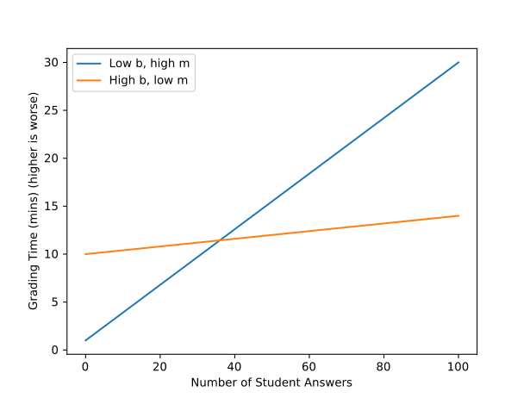
(For illustrative purposes only. Not based on actual data.)
It is for this reason that grading software that automates away the more tedious parts of grading—shuffling papers, writing down scores, and other organizational tasks—is necessary. Although such software has a higher initial cost due to the need for digital scans of student papers, the overall cost will still be lower, especially as the number of student answers being graded increases.
I created the MarkSpace grading software to do exactly that. It takes scanned student answers and presents them to the grader sorted by the question that each answer is answering. This way, it is possible to grade all student answers to question #1 before advancing to the next question. This method of grading allows teachers to focus on one question, instantly pattern-recognizing correct answers, rather than having to grade questions in the sequence in which they appeared. This streamlining of the grading process aims to bring the same benefits that assembly lines brought to the Industrial Revolution: speed, quality, and repeatability.
Language Choices
Choosing a programming language for a project is a complex and often impossible decision. This table lays out my rationale for choosing the languages I used.
Programming Language | Where | Why
Java (OpenJDK, not Oracle) | Backend (business logic) | - Cross-platform (can run on MacOS, Windows, and GNU/Linux without code changes)  - Chosen language of the AP Computer Science A class – means that it will be easy to find Java programmers at Foothill HS to maintain the software in future  - Many available libraries for web server-related tasks
JS/TypeScript (Microsoft, but open source) | Client-side | - Better for building large, complex applications than plain JavaScript  - Compiles to plain JavaScript, so the user never sees any difference
SQL | Database queries | - No choice here; pretty much every relational database uses SQL as its query language
HTML5 | User interface | - No choice here; this is the language of the Web
Velocity Templating Language (VTL) | Server-side templating | - No choice here; this is the default templating language of the Spark web framework
CSS | Stylesheets | - No choice here; this is the styling language of the Web

External Libraries/Tools Used
Numerous libraries and tools written by other programmers were used for this project. Libraries internal to Java or TypeScript are not included here. Here they are:
Library/Tool | Where | Why
Maven | Java build system | Helps manage dependencies and automate the build process. Fairly standard for Java projects.
Spark Java | Web framework | Provides an easy-to-use way to write medium-sized web apps, with routing and templating functionality, along with convenience APIs to access sessions/cookies/requests without directly accessing the Servlet API.
Simple Logging Framework for Java (SLF4J) | Logging for Spark Java | Required by Spark Java.
Velocity Templating Engine | Server-side templating | Default templating engine of Spark Java.
Apache PDFBox | PDF Rendering | Allows turning PDFs into raster images for display. PDF is one of the most complicated file formats to implement; I’m not going to spend 20 years developing a viable alternative to PDFBox.
JSON Sanitizer | Server-side JSON processing | Removes potentially malformed or malicious content from JSON data.
Google Gson | Server-side JSON processing | Allows turning JSON objects received from clients into Java objects for server-side operations.
OpenCSV | Server-side CSV creation | Reads and writes CSV files. Handles automatic quoting of CSV data that contains separators/spaces.
SQLite (with Xerial’s JDBC plugin) | Server-side relational database storage | I decided to use a relational database as the persistent storage mechanism because that remains the standard for enterprise storage of large amounts of connected data. The SQLite engine allows fast querying of the data.
JQuery | Client-side DOM manipulation and HTTP requests | Mainly used as a slightly less verbose DOM manipulation and AJAX syntax. Also acts as a shim for legacy browsers.
Vue.js | Client-side templating | For the more dynamic pages, a bidirectional data binding framework is necessary to translate raw JSON retrieved from the server into a live user interface.
Architecture

